Regular Expressions in Python
Regular expressions, or "regex" for short, are a powerful tool for working with strings and text data in Python. They allow you to match and manipulate strings based on patterns, making it easy to perform complex string operations with just a few lines of code.
Metacharacters in regular expressions
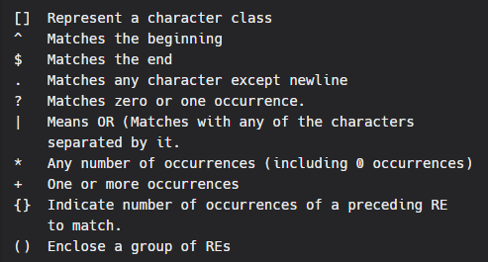
Find list of more meta characters here - https://www.ibm.com/docs/en/rational-clearquest/9.0.1?topic=tags-meta-characters-in-regular-expressions
Importing re Package
In Python, regular expressions are supported by the re module. The basic syntax for working with regular expressions in Python is as follows:
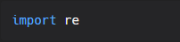
Searching for a pattern in re using re.search() Method
re.search() method either returns None (if the pattern doesn’t match), or a re.MatchObject that contains information about the matching part of the string. This method stops after the first match, so this is best suited for testing a regular expression more than extracting data. We can use re.search method like this to search for a pattern in regular expression:
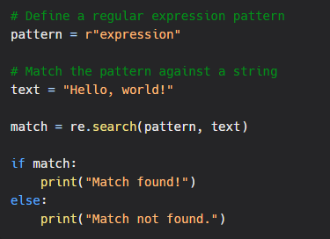
Searching for a pattern in re using re.findall() Method
You can also use the re.findall function to find all occurrences of the pattern in a string:
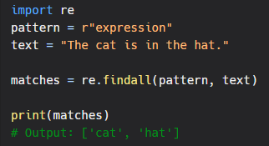
Replacing a pattern
The following example shows how to replace a pattern in a string:
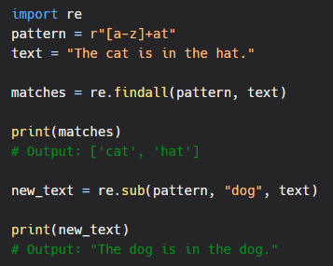
Extracting information from a string
The following example shows how to extract information from a string using regular expressions:
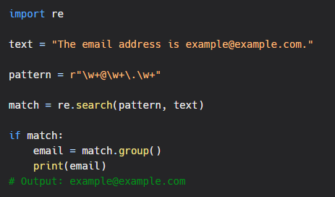

Conclusion
Regular expressions are a powerful tool for working with strings and text data in Python. Whether you're matching patterns, replacing text, or extracting information, regular expressions make it easy to perform complex string operations with just a few lines of code. With a little bit of practice, you'll be able to use regular expressions to solve all sorts of string-related problems in Python.

